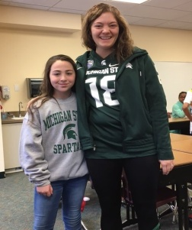
Wow! Here a few snapshots of the fun we had last week. We wore red and white for school spirit, dressed in lots of sports paraphernalia, pretended to be royalty, played class games in the color blue, completed service projects, and celebrated the legacy of Mr. Mortensen.

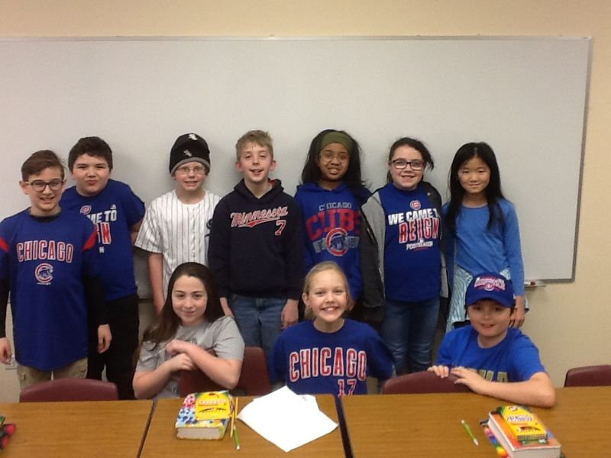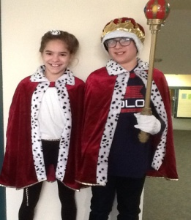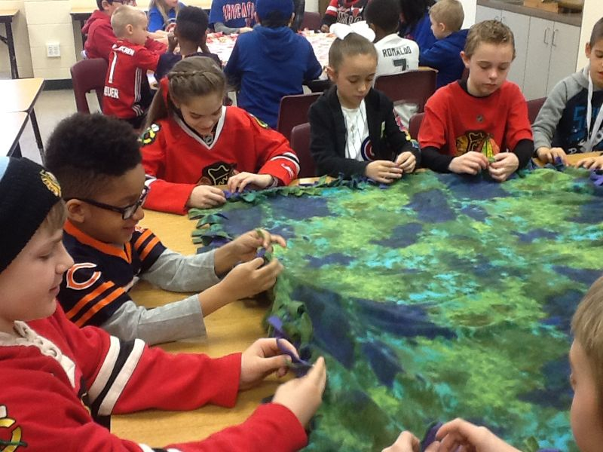
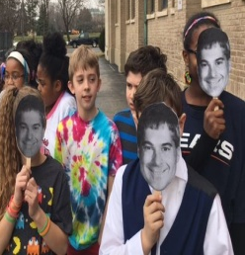
The kids were very enthusiastic about bringing monies for the Fine Arts Fund in Need. It was exciting for them to collect and count and we exceed our class goals. The week ended on a high note with Graceful Evening and it was great to see so many of you in attendance. Thanks for support with all these activities.

We finished our class novel last week, Tuck Everlasting. The kids were very involved in the plot line and it is always the cause of some interesting discussion. Ask your student about the term immortality and the dilemma it caused in the book.

Also last week, we were visited by Pastor Lauren Wegner to talk about Jesus’ first disciples. It was a great way to wrap up our studies and an opportunity for question asking.

Finally, although the last week before Spring break, we buckle down and wrap up a few loose ends. Check the class website for details about tests and a writing assignment.

Together in Christ,
Mrs. Massmann

