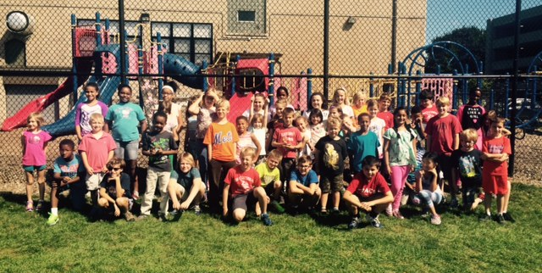
September 6, 2016
Dear Parents,
Thank you for attending the Curriculum Open House Night last week. It was a productive time together and I very much appreciate your support at home. Although this is a short week, it is filled with academics, athletics, and band begins. Using the class website www.allthingsgrade5.weebly.com and by clicking on the resources tab, parents and students can view a variety of textbooks, other class websites, and power school- the online grade book. Please ask if you need help.
Last week we welcomed Pastor Dave Lyle to our classroom for some time of questions and answers about the Bible. The students amazed me with not just their previous knowledge but the depth of questions that were posed to Pastor Lyle. We had a heartfelt conversation about what God wants for all of his children and how sin can interfere. It was clear that images and events in our neighborhoods and around the world are things that our children are thinking about and trying to reconcile. We lifted those concerns and other prayers to God.
In Grade 5 reading and writing this week, we will use a non-fiction story about architect May Lin story to inspire our first formal writing assignment. Lin is the architect of several buildings and monuments including the Vietnam Veterans Memorial in Washington D.C. and we will examine how Lin used materials and design to honor those who fought. As a way to compare and contrast memorials, we will discover how the 9/11 memorial, although constructed differently, is also a place of remembrance. Our focus will be the memorials, not the events leading up to them, which will give us the information to compare and contrast.
Religion | The Bible / Memory: The first 12 books of the OT
Reading | May Lin: Architect of a Dream
Writing & Grammar | Compare & Contrast Memorials/ Transition Words
Spelling | Lesson 2- WB due Thurs/ Test Fri
Science | Chapter 1- Lesson 4 and review
Vocabulary- 6th | Review of L 1 words
Reading- 6th | Essential Story Elements/ The Good Deed
Writing & Grammar- 6th | Response to Literature based on When You Reach Me- summer novel

Together in Christ,
Mrs. Massmann
rmassmann@graceriverforest.org
P.S. Photo above is from a cooperative game with our second grade chapel partners. It was a great ending to our Friday afternoon. We are building relationships and learning the qualities of effective leadership.

