April 4, 2017

Dear Fifth Grade Families,

With Spring break behind us, we make one final push to the end of the school year. We have lots to do between now and June. One specific learning opportunity is the Science Fair project. With a school-wide initiative on providing STEM experiences, fifth graders will participate in the egg drop challenge. The objective is to design a system to protect an egg from cracking or breaking from a high fall. Each student will create an apparatus at home that will be tested three times at school. We will use class time to complete research, test, and write about results. All the details are in the packet distributed yesterday, April 3. The Science Fair is Thursday, April 20.
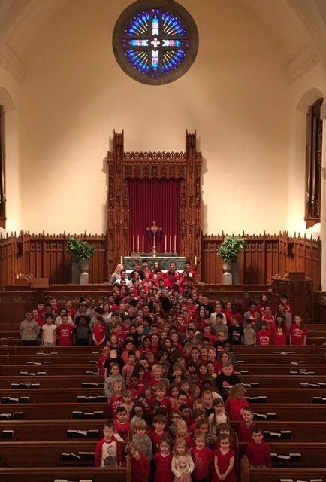
In mid-March we assembled as Literature Circles groups again. The students have done an excellent job reading, completing tasks, and leading quality discussions within their groups. From now until mid-May, groups may choose their own pacing for book reading with the completion of two books as the minimum standard. It will be exciting to observe their success.
Each Tuesday afternoon, Officer Czernik from the River Forest Police Department leads the program entitled, “Too Good for Drugs.” The students enjoy learning from him and he will be here weekly until mid-May.
Finally, the Tuesday folders are quite full this week. In the days prior to break, we wrapped up several curricular topics with projects, essays, and tests. As a friendly reminder, please remove the contents, initial the folder, and your child should return the folder to school on Wednesday.
Together in Christ,

Mrs. Massmann All school photo from LSW- we are the left arm of the cross
www.allthingsgrade5.weebly.com

