April 25, 2017
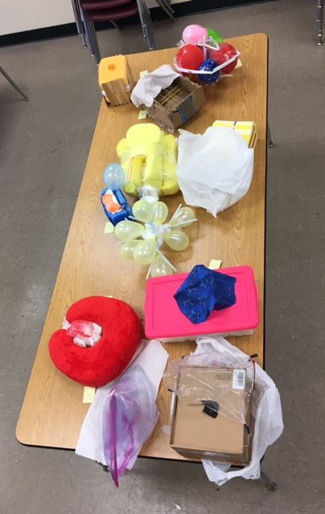
Dear Fifth Grade Families,
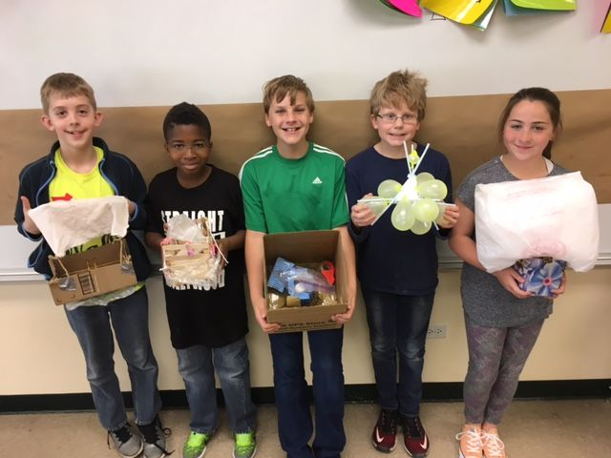
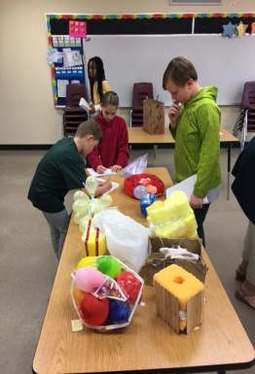
Thanks for your support with the Science Fair. The students approached the task with great enthusiasm which made the process enjoyable. I especially enjoyed seeing the uniqueness of each container and the changes throughout the process. As a class, every container passed level one, more than 15 feet, off level one of the parking garage. Some students also experienced success at other heights and five eggs survived the final fall from the roof of the parking garage, 45 feet, in five differently constructed containers. The Lab Report, Certificate of Achievement, and rubric are included in your folder. Great Job!
This week we work on wrapping up our Poetry Unit. Thursday, April 27 is “Poem in Your Pocket Day.” All students should bring a poem of their choice for sharing at school. In addition to participating in this event with the rest of the school, we’ll also have an Author’s breakfast for sharing our original works of poetry. See the folder for a separate note if your student has volunteered to bring an item.
Our Literature Circles have been self-pacing reading amounts. It’s great to see the students take the imitative to do so. Hopefully you’ve noticed your student reading with more frequency. We will have summer reading lists and requirements at the last parent-teacher conference.
Good Luck to Fine Arts Performers on Friday. For those who are NOT attending the Fine Arts Festival on Friday, April 28, we are headed to Walther High School for a morning show of The Little Mermaid. I need permission forms since we are traveling in cars and $1 for the show. Please return ASAP.
Together in Christ,
Mrs. Massmann
www.allthingsgrade5.weebly.com

